**PRACTICAL-1**

**AIM:**

Study and compare different software process models and compare them based on cost, simplicity, risk, involvement of user, flexibility, maintenance, integrity, security, re-usability, and requirement.

**Software requirement**: none.

**Knowledge required**: SDLC models

SOL:

Software Development Life Cycle (SDLC) is a process used by the software industry to design, develop and test high quality softwares. The SDLC aims to produce a high-quality software that meets or exceeds customer expectations, reaches completion within times and cost estimates.

* SDLC is the acronym of Software Development Life Cycle.
* It is also called as Software Development Process.
* SDLC is a framework defining tasks performed at each step in the software development process.
* ISO/IEC 12207 is an international standard for software life-cycle processes. It aims to be the standard that defines all the tasks required for developing and maintaining software.

The following figure is a graphical representation of the various stages of a typical SDLC.

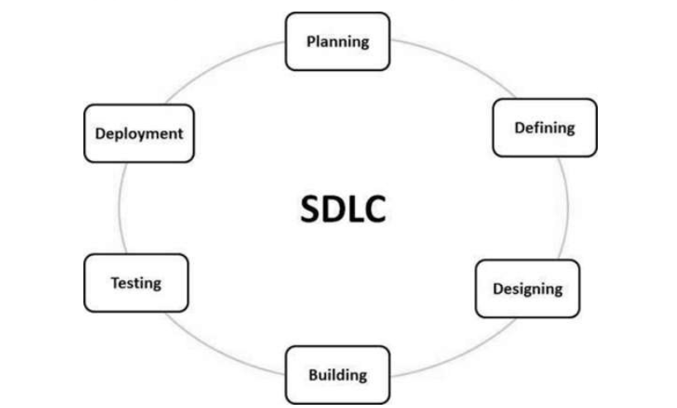

There are various software development life cycle models defined and designed which are followed during the software development process.

There are 9 SDLC models:

1. WaterFall Model

2. Iterative Model

3. Incremental Model

4. RAD Model

5. Spiral Model

6. Prototype Model

7. Evolutionary Model

8. V Model

9. Agile Model

**1. Waterfall Model:**Waterfall approach was first SDLC Model to be used widely in Software Engineering to ensure success of the project. In "The Waterfall" approach, the whole process of software development is divided into separate phases.

Phases of Waterfall Model:

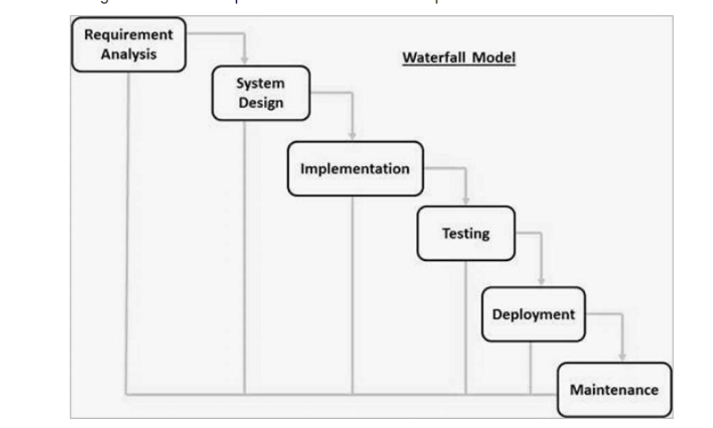

**Advantages:**

Some of the major advantages of the Waterfall Model are as follows −

* Simple and easy to understand and use
* Easy to manage due to the rigidity of the model. Each phase has specific deliverables and a review process.
* Phases are processed and completed one at a time.
* Works well for smaller projects where requirements are very well understood.
* Clearly defined stages.
* Well understood milestones.
* Easy to arrange tasks.
* Process and results are well documented.

**Disadvantages:**

The major disadvantages of the Waterfall Model are as follows −

* No working software is produced until late during the life cycle.
* High amounts of risk and uncertainty.
* Not a good model for complex and object-oriented projects.
* Poor model for long and ongoing projects.
* Not suitable for the projects where requirements are at a moderate to high risk of changing. So, risk and uncertainty is high with this process model.
* It is difficult to measure progress within stages.
* Cannot accommodate changing requirements.
* Adjusting scope during the life cycle can end a project.
* Integration is done as a "big-bang. at the very end, which doesn't allow identifying any technological or business bottleneck or challenges early.

**Waterfall Model - Application**

Every software developed is different and requires a suitable SDLC approach to be followed based on the internal and external factors. Some situations where the use of Waterfall model is most appropriate are −

* Requirements are very well documented, clear and fixed.
* Product definition is stable.
* Technology is understood and is not dynamic.
* There are no ambiguous requirements.
* Ample resources with required expertise are available to support the product.
* The project is short.

**2. Iterative Model**: Iterative process starts with a simple implementation of a subset of the software requirements and iteratively enhances the evolving versions until the full system is implemented. At each iteration, design modifications are made and new functional capabilities are added. The basic idea behind this method is to develop a system through repeated cycles (iterative) and in smaller portions at a time (incremental).

Phases of Iterative Model:

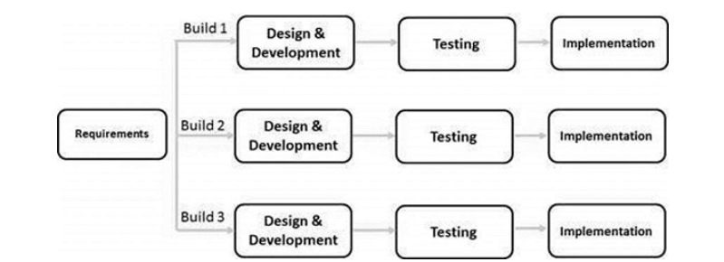.

**Advantages:**

The advantages of the Iterative are as follows −

* Some working functionality can be developed quickly and early in the life cycle.
* Results are obtained early and periodically.
* Parallel development can be planned.
* Progress can be measured.
* Less costly to change the scope/requirements.
* Testing and debugging during smaller iteration is easy.
* Risks are identified and resolved during iteration; and each iteration is an easily managed milestone.
* Easier to manage risk - High risk part is done first.
* With every increment, operational product is delivered.
* Issues, challenges and risks identified from each increment can be utilized/applied to the next increment.
* Risk analysis is better.
* It supports changing requirements.
* Initial Operating time is less.
* Better suited for large and mission-critical projects.
* During the life cycle, software is produced early which facilitates customer evaluation and feedback.

**Disadvantages:**

The disadvantages of the Iterative SDLC Model are as follows −

* More resources may be required.
* Although cost of change is lesser, but it is not very suitable for changing requirements.
* More management attention is required.
* System architecture or design issues may arise because not all requirements are gathered in the beginning of the entire life cycle.
* Defining increments may require definition of the complete system.
* Not suitable for smaller projects.
* Management complexity is more.
* End of project may not be known which is a risk.
* Highly skilled resources are required for risk analysis.
* Projects progress is highly dependent upon the risk analysis phase.

**Iterative Model - Application**

Like other SDLC models, Iterative and incremental development has some specific applications in the software industry. This model is most often used in the following scenarios −

* Requirements of the complete system are clearly defined and understood.
* Major requirements must be defined; however, some functionalities or requested enhancements may evolve with time.
* There is a time to the market constraint.
* A new technology is being used and is being learnt by the development team while working on the project.
* Resources with needed skill sets are not available and are planned to be used on contract basis for specific iterations.
* There are some high-risk features and goals which may change in the future.

**3. Incremental Model:** Incremental Model is a process of software development where requirements divided into multiple standalone modules of the software development cycle. In this model, each module goes through the requirements, design, implementation and testing phases. Every subsequent release of the module adds function to the previous release. The process continues until the complete system achieved.

Phases of Incremental Model:

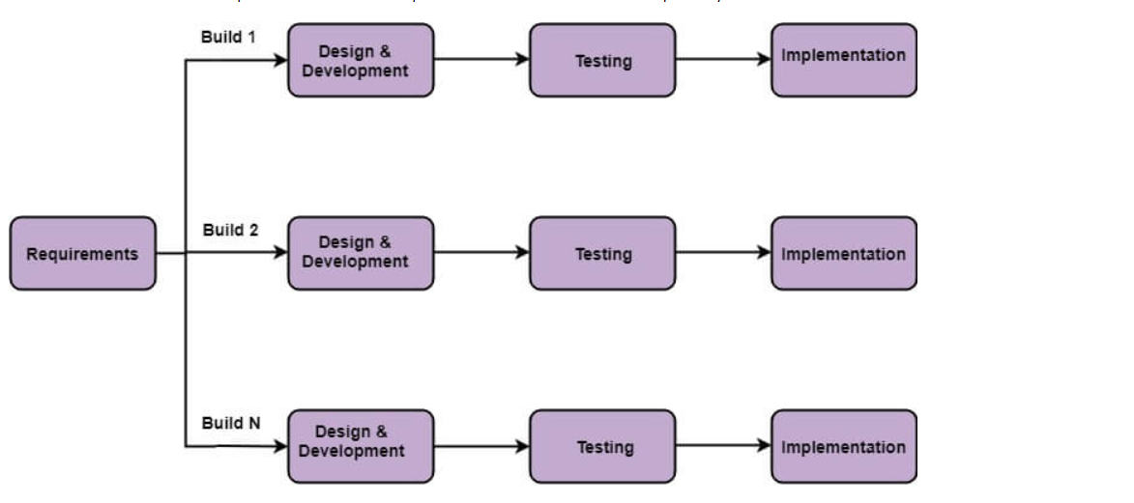

**When we use the Incremental Model?**

* When the requirements are superior.
* A project has a lengthy development schedule.
* When Software team are not very well skilled or trained.
* When the customer demands a quick release of the product.
* You can develop prioritized requirements first.

**Advantages:**

The advantages of theIncremental are as follows −

* Some working functionality can be developed quickly and early in the life cycle.
* Results are obtained early and periodically.
* Parallel development can be planned.
* Progress can be measured.
* Less costly to change the scope/requirements.
* Testing and debugging during smaller iteration is easy.
* Risks are identified and resolved during iteration; and each iteration is an easily managed milestone.
* Easier to manage risk - High risk part is done first.
* With every increment, operational product is delivered.

**Disadvantages:**

The disadvantages of the Incremental SDLC Model are as follows −

* More resources may be required.
* Although cost of change is lesser, but it is not very suitable for changing requirements.
* More management attention is required.
* System architecture or design issues may arise because not all requirements are gathered in the beginning of the entire life cycle.
* Defining increments may require definition of the complete system.
* Not suitable for smaller projects.
* Management complexity is more.

**4. RAD Model:** Rapid application development is a software development methodology that uses minimal planning in favor of rapid prototyping. A prototype is a working model that is functionally equivalent to a component of the product.

In the RAD model, the functional modules are developed in parallel as prototypes and are integrated to make the complete product for faster product delivery. Since there is no detailed preplanning, it makes it easier to incorporate the changes within the development process.

RAD projects follow iterative and incremental model and have small teams comprising of developers, domain experts, customer representatives and other IT resources working progressively on their component or prototype.

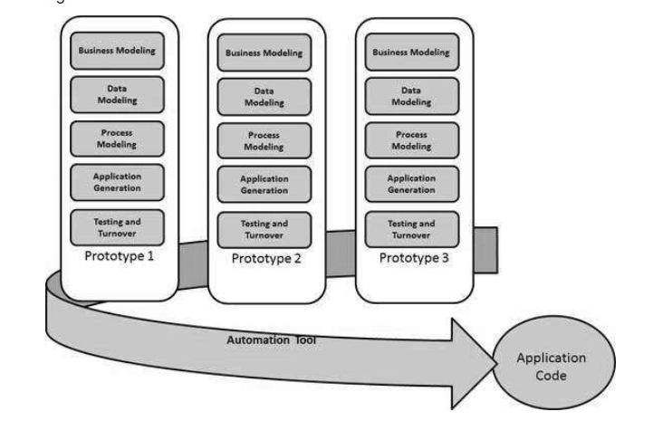

**Advantages:**

The advantages of the RAD Model are as follows −

* Changing requirements can be accommodated.
* Progress can be measured.
* Iteration time can be short with use of powerful RAD tools.
* Productivity with fewer people in a short time.
* Reduced development time.
* Increases reusability of components.
* Quick initial reviews occur.
* Encourages customer feedback.
* Integration from very beginning solves a lot of integration issues.

**Disadvantages:**

The disadvantages of the RAD Model are as follows −

* Dependency on technically strong team members for identifying business requirements.
* Only system that can be modularized can be built using RAD.
* Requires highly skilled developers/designers.
* High dependency on Modelling skills.
* Inapplicable to cheaper projects as cost of Modelling and automated code generation is very high.
* Management complexity is more.
* Suitable for systems that are component based and scalable.
* Requires user involvement throughout the life cycle.
* Suitable for project requiring shorter development times.

**RAD Model - Application**

RAD model can be applied successfully to the projects in which clear modularization is possible. If the project cannot be broken into modules, RAD may fail.

The following pointers describe the typical scenarios where RAD can be used −

* RAD should be used only when a system can be modularized to be delivered in an incremental manner.
* It should be used if there is a high availability of designers for Modelling.
* It should be used only if the budget permits use of automated code generating tools.
* RAD SDLC model should be chosen only if domain experts are available with relevant business knowledge.
* Should be used where the requirements change during the project and working prototypes are to be presented to customer in small iterations of 2-3 months.

**5. Spiral Model:** The spiral model combines the idea of iterative development with the systematic, controlled aspects of the waterfall model. This Spiral model is a combination of iterative development process model and sequential linear development model i.e. the waterfall model with a very high emphasis on risk analysis. It allows incremental releases of the product or incremental refinement through each iteration around the spiral.

There are four phases of Spiral model:

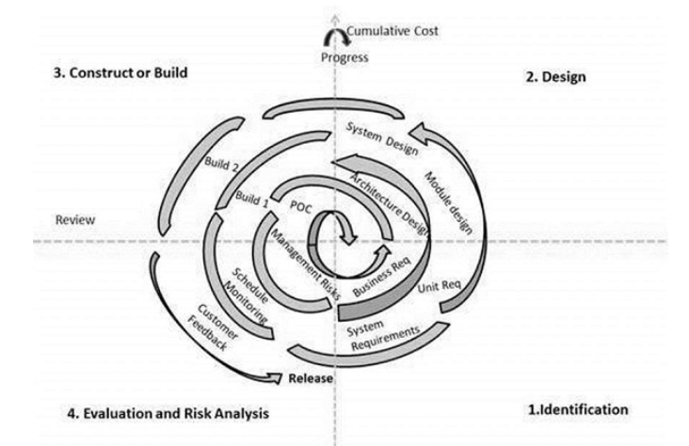

**Advantages:**

The advantages of the Spiral SDLC Model are as follows −

* Changing requirements can be accommodated.
* Allows extensive use of prototypes.
* Requirements can be captured more accurately.
* Users see the system early.
* Development can be divided into smaller parts and the risky parts can be developed earlier which helps in better risk management.

**Disadvantages:**

The disadvantages of the Spiral SDLC Model are as follows −

* Management is more complex.
* End of the project may not be known early.
* Not suitable for small or low risk projects and could be expensive for small projects.
* Process is complex
* Spiral may go on indefinitely.
* Large number of intermediate stages requires excessive documentation.

**Spiral Model Application:**

The Spiral Model is widely used in the software industry as it is in sync with the natural development process of any product, i.e. learning with maturity which involves minimum risk for the customer as well as the development firms.

The following pointers explain the typical uses of a Spiral Model −

* When there is a budget constraint and risk evaluation is important.
* For medium to high-risk projects.
* Long-term project commitment because of potential changes to economic priorities as the requirements change with time.
* Customer is not sure of their requirements which is usually the case.
* Requirements are complex and need evaluation to get clarity.
* New product line which should be released in phases to get enough customer feedback.
* Significant changes are expected in the product during the development cycle.

**6. Prototype Model:** Prototype is a working model of software with some limited functionality. The prototype does not always hold the exact logic used in the actual software application and is an extra effort to be considered under effort estimation.

Prototyping is used to allow the users evaluate developer proposals and try them out before implementation. It also helps understand the requirements which are user specific and may not have been considered by the developer during product design.

Phases :

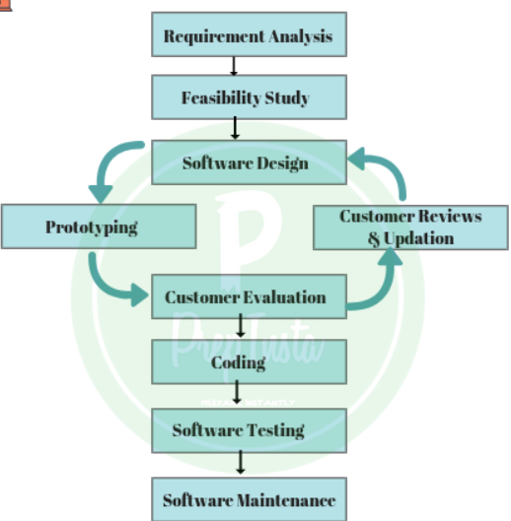

**Advantages:**

The advantages of the Prototyping Model are as follows −

* Increased user involvement in the product even before its implementation.
* Since a working model of the system is displayed, the users get a better understanding of the system being developed.
* Reduces time and cost as the defects can be detected much earlier.
* Quicker user feedback is available leading to better solutions.
* Missing functionality can be identified easily.
* Confusing or difficult functions can be identified.

**Disadvantages:**

The Disadvantages of the Prototyping Model are as follows −

* Risk of insufficient requirement analysis owing to too much dependency on the prototype.
* Users may get confused in the prototypes and actual systems.
* Practically, this methodology may increase the complexity of the system as scope of the system may expand beyond original plans.
* Developers may try to reuse the existing prototypes to build the actual system, even when it is not technically feasible.
* The effort invested in building prototypes may be too much if it is not monitored properly.

**Software Prototyping - Application**

Software Prototyping is most useful in development of systems having high level of user interactions such as online systems. Systems which need users to fill out forms or go through various screens before data is processed can use prototyping very effectively to give the exact look and feel even before the actual software is developed.

Software that involves too much of data processing and most of the functionality is internal with very little user interface does not usually benefit from prototyping. Prototype development could be an extra overhead in such projects and may need lot of extra efforts.

**7. Evolutionary Model:** Evolutionary model is a combination of [Iterative](https://www.geeksforgeeks.org/software-engineering-iterative-waterfall-model/)and [Incremental model](https://www.geeksforgeeks.org/software-engineering-incremental-process-model/) of software development life cycle. Delivering your system in a big bang release, delivering it in incremental process over time is the action done in this model. Some initial requirements and architecture envisioning need to be done.

It is better for software products that have their feature sets redefined during development because of user feedback and other factors. The Evolutionary development model divides the development cycle into smaller, incremental waterfall models in which users are able to get access to the product at the end of each cycle.

Phases:

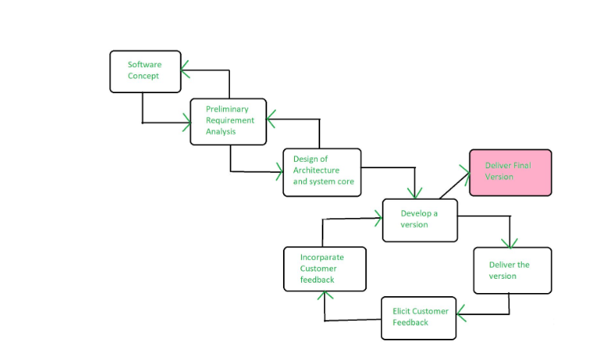

**Advantages:**

* In evolutionary model, a user gets a chance to experiment partially developed system.
* It reduces the error because the core modules get tested thoroughly.

**Disadvantages:**

* Sometimes it is hard to divide the problem into several versions that would be acceptable to the customer which can be incrementally implemented and delivered.

**Application of Evolutionary Model:**

1. It is used in large projects where you can easily find modules for incremental implementation. Evolutionary model is commonly used when the customer wants to start using the core features instead of waiting for the full software.
2. Evolutionary model is also used in object oriented software development because the system can be easily portioned into units in terms of objects.

**8. V Model:** The V-model is an SDLC model where execution of processes happens in a sequential manner in a V-shape. It is also known as **Verification and Validation model**.

The V-Model is an extension of the waterfall model and is based on the association of a testing phase for each corresponding development stage. This means that for every single phase in the development cycle, there is a directly associated testing phase. This is a highly-disciplined model and the next phase starts only after completion of the previous phase.

**Phases:**

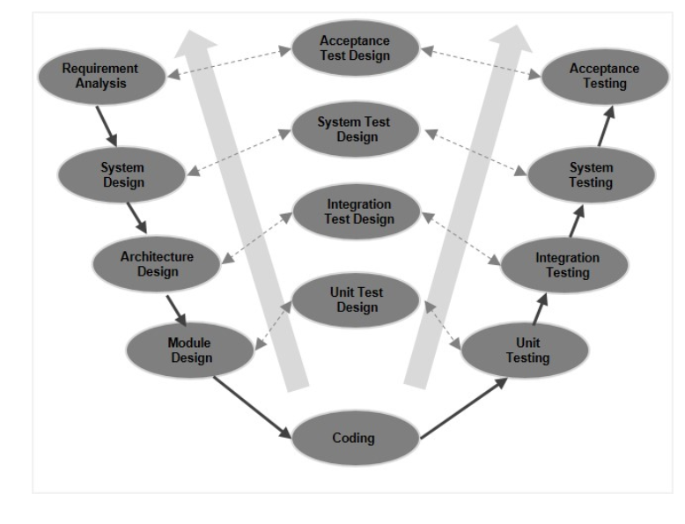

**Advantages:**

The advantages of the V-Model method are as follows −

* This is a highly-disciplined model and Phases are completed one at a time.
* Works well for smaller projects where requirements are very well understood.
* Simple and easy to understand and use.
* Easy to manage due to the rigidity of the model. Each phase has specific deliverables and a review process.

**Disadvantages:**

The disadvantages of the V-Model method are as follows −

* High risk and uncertainty.
* Not a good model for complex and object-oriented projects.
* Poor model for long and ongoing projects.
* Not suitable for the projects where requirements are at a moderate to high risk of changing.
* Once an application is in the testing stage, it is difficult to go back and change a functionality.
* No working software is produced until late during the life cycle.

**V- Model ─ Application:**

V- Model application is almost the same as the waterfall model, as both the models are of sequential type. Requirements have to be very clear before the project starts, because it is usually expensive to go back and make changes. This model is used in the medical development field, as it is strictly a disciplined domain.

The following pointers are some of the most suitable scenarios to use the V-Model application.

* Requirements are well defined, clearly documented and fixed.
* Product definition is stable.
* Technology is not dynamic and is well understood by the project team.
* There are no ambiguous or undefined requirements.
* The project is short.

**9. Agile Model:** Agile model believes that every project needs to be handled differently and the existing methods need to be tailored to best suit the project requirements. In Agile, the tasks are divided to time boxes (small time frames) to deliver specific features for a release.

Iterative approach is taken and working software build is delivered after each iteration. Each build is incremental in terms of features; the final build holds all the features required by the customer.

Phases:

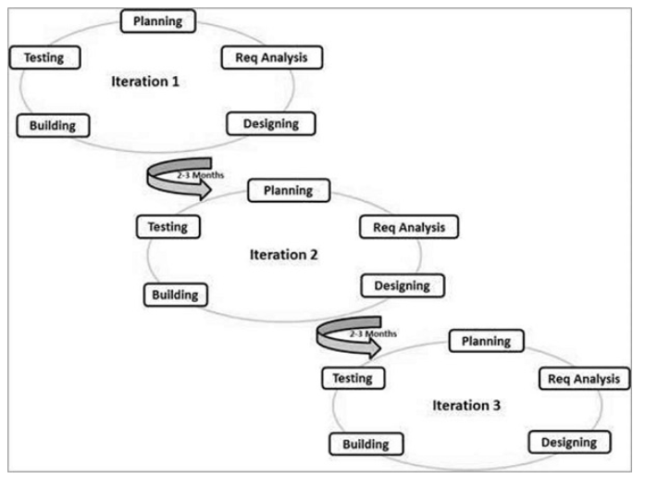

**Advantages:**

The advantages of the Agile Model are as follows −

* Is a very realistic approach to software development.
* Promotes teamwork and cross training.
* Functionality can be developed rapidly and demonstrated.
* Resource requirements are minimum.
* Suitable for fixed or changing requirements
* Delivers early partial working solutions.
* Good model for environments that change steadily.
* Minimal rules, documentation easily employed.
* Enables concurrent development and delivery within an overall planned context.
* Little or no planning required.
* Easy to manage.
* Gives flexibility to developers.

**Disadvantages:**

The disadvantages of the Agile Model are as follows −

* Not suitable for handling complex dependencies.
* More risk of sustainability, maintainability and extensibility.
* An overall plan, an agile leader and agile PM practice is a must without which it will not work.
* Strict delivery management dictates the scope, functionality to be delivered, and adjustments to meet the deadlines.
* Depends heavily on customer interaction, so if customer is not clear, team can be driven in the wrong direction.
* There is a very high individual dependency, since there is minimum documentation generated.
* Transfer of technology to new team members may be quite challenging due to lack of documentation.

**COMPARISONS BETWEEN SDLC MODELS:**

|  |  |  |  |  |  |  |  |  |
| --- | --- | --- | --- | --- | --- | --- | --- | --- |
| Parameters/Merits | Waterfall | Iterative | Prototype | RAD | Incremental | Spiral | Evolutionary | Agile |
| Cost | High | Low | High | Low | Low | High | Low | Low |
| Simplicity | Simple | Simple | Low | Simple | Medium | Medium | Medium | Simple |
| Success Rate | Low | High | Good | Good | Good | High | High | Good |
| Involvement of Users | At Analysis Time | Yes | High | Yes | Yes | High | Yes | High |
| Flexibility | No | Good | No | Yes | Low | Yes | Yes | Yes |
| Reusability | Limited | Yes | Yes | Yes | Yes | Yes | Yes | Limited |
| Security | Vital | Limited | Week |  |  | High |  |  |
| Development Time | Long | Medium | Long | Quick | Long | Long | Less | Fixed |
| Overlapping Phases | No | Yes | Yes | No | Yes | Yes |  | No |
| Incorporations of Changes | Difficult | Easy | Easy | Easy | Easy | Easy | Easy | Easy |
| Requirement Specifications | Yes | Yes | No | Yes | No | No | Yes | Yes |

(1.9) Comparison of Different SDLC Models

# Conclusion: In this practical, I gain knowledge about different SDLC (Software Development Life Cycle) models and at last I compared them compare them based on cost, simplicity, risk, involvement of user, flexibility, maintenance, integrity, security, re-usability, and requirement.